Union Baptist Church 1st Annual Bike and Car Show May 6, 2017 Starting at 11:00 A.M.
Union Missionary Baptist Church 2470 Bruce Street Lithonia, Ga. 30058 Pastor Edward L. Randolph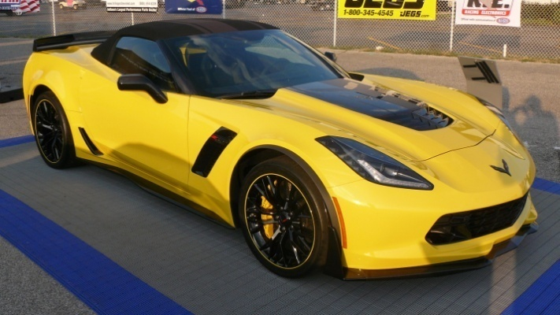 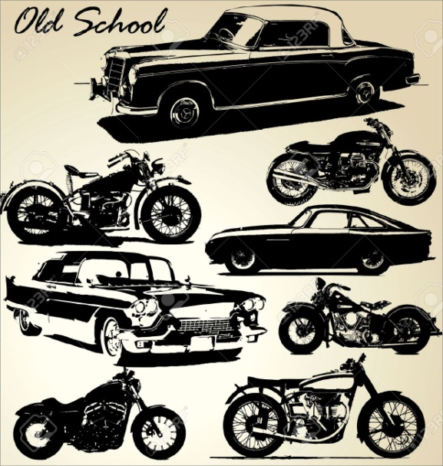
Food will be Sold by the Church

Cash Only -______ Amount Paid
Name__________________________ Phone Number_____________ Email address_______________
Type Vehicle______________ Color __________ Year_________
I’m a member ____________________________ Club___________
Owner Signature__________________________ Enter Number____________________
Winner Prizes in A. Best Hot Rod B. Corvette C. Bike
People choice as voted by people attending event
1 and 2 Place Prize given to each above class
Entrée Fee $25.00 per vehicle
All Proceeds from event Union Baptist Church
Judging from 12: P.M. until 2: P.M.

